Second Hand Machinery: Import / Export Guide
erica0412
Jun 5, 2024
1 min read

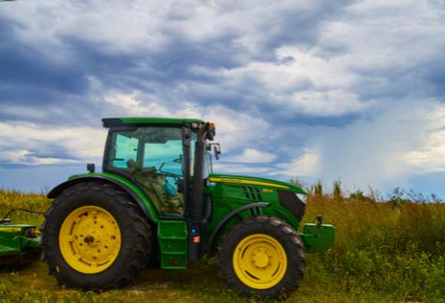
Requirements for Importing from Britain:

Register with the Department of Agriculture & TRACES NT.

A phytosanitary certificate is required, and will be provided by the UK’s National Plant Protection Organisation (NPPO).

All documents are to be submitted to the Department at least 24 hours before arrival of consignment; Part 1 of TRACES NT’s Common Health Entry Documents for Plants and Plant Products (CHED-PP) must be completed, physical checks on arrival.

Requirements for Exporting to Britain:

Register with the Department of Agriculture A phytosanitary certificate, must be applied for through the department 14 days before the departure of the consignment & must be sent to the British buyer before departure of the consignment The British buyer must submit documents to the authorities atleast 4 hours in advance of arrival if traveling by air, and 1 day if traveling by road / sea.

Important to Note:

Machinery subject to these requirements include: tractors, horticultural / forestry machinery for soil preparation / cultivation, harvesting / threshing machinery (including straw / fodder balers), grass / hay mowers, machines for cleaning / sorting / grading eggs, fruit or other agricultural produce, poultry / bee-keeping machinery (including germination plant fitted with mechanical or thermal equipment) and poultry incubators & brooders. The machinery must be clean & free of soil / plant debris.

www.customswise.ie | 01 8665644 | info@customswise.ie

